Background

Both natural and manmade tragedies have taken the spotlight in national and global media, and rightfully so. Recent attacks have killed and injured hundreds, and many have been the result of unregulated gunfire and improvised explosive devices (IEDs). The Boston Marathon bombing on April 15, 2013 was caused by two, homemade, pressure cooker bombs that left 3 dead and 265 injured (Lessons from Boston, Kellerman NEJM). The November 2015 Paris attacks were coordinated terrorist attacks which combined mass shootings with suicide bombings that left 129 dead, and 352 injured (\*\*\* citation needed). The 2015 San Bernardino attack on December 2 was the result of two radicals with unregulated gunfire that left 14 dead and 22 wounded (\*\*\* citation needed). Our hearts are with the victims and their families.

The victims of any major, life-threatening event rely on the immediate response of emergency medical personnel. EMS personnel strive for an 8-minute response time (\*\*\* citation needed). However, under active shooter incidents protocol dictates that the perimeter first be secured, and the threat level of the area be transitioned from a “hot zone” to, at least, a “warm zone” which can delay response and direct medical attention anywhere from 10 minutes to 2 hours (\*\*\* citation needed). Thus, victims of an active shooter incident may be delayed in receiving healthcare (LAWA report 2013). This leaves a major time gap in receiving healthcare and life-saving treatment that only a first care provider can address.

The concept of “civilian survivability” in typical and atypical disasters has been widely recognized. There has been consensus amongst trauma providers and EMS systems that a community response is needed. The TECC has created guidelines providing the evidence to support such an effort (TECC Guidelines, Callaway PDF). Subsequently, the Hartford Consensus III of 2014 documented the need for “empowering the public to provide emergency care” and recognizing hemorrhage control (Hartford Concensus III, Dr. Jacobs , Bulletin American College of Surgeons). Most recently, In 2015, the United States Department of Homeland Security announced the “Stop the Bleed” campaign, which recognized the need for hemorrhage control through the use of pressure and tourniquets but also failed to provide instruction and incorporation to the public (DHS.gov). Tourniquets are indeed one of the most effective treatments for hemorrhaging, and have been documented in comprehensive studies over the past several years (\*\*\* citation needed). This recognition is a step toward placing power in the hands of the first care provider. Yet the problem systemically has been one of implementation. To date, none of the existing programs provide a framework for how treatment incorporates into disaster education to the general public.

Recent events have revealed that access to the wounded, recognition of significant injury, and rapid evacuation to medical care are at least equally important as immediate hemorrhage control (Aurora). In Journal of Trauma, a framework was proposed of how these concepts could be incorporated through government regulation, public access to trauma equipment, first responder training, and first care provider training. This study will document how these simple ideas can be put into practice. We provided basic training and resources to volunteers from the general public and monitored their actions to a natural disaster simulation. If the civilians in the public setting given training and resources outlined in “The White Paper”, they can learn to assess, treat, and solve the most common causes of death during disaster scenarios and improve life expectancy.

Materials and Methods

Participants

Participants for this study were obtained as volunteers through the Westminster Police Department. Volunteers included registered nurses and nursing undergraduate students, local teachers, local city workers, local security guards, undergraduate students and EMS personnel from the Orange County Fire Authority. Registered nurses and nursing undergraduate students were used as reference groups for their foundations in providing medical treatment. Teachers, city workers, security guards, and students, were randomly placed into 2 groups: trained individuals and untrained individuals. EMS personnel served as a baseline, as they are already trained to respond to any natural or manmade disaster.

Training

The trained group was given a 2-hour TCCC training overview 6 weeks prior to the conduction of the simulation. Training detailed as follows: Dr. Bobko

Pre-test Questions

Prior to participation in the natural disaster simulation, all participants were given a pre-test with self-identification followed by 14 questions. Participants first recognized their level of training by answering whether they were First Care Provider Trained or a Professional Medical Provider. The 14 questions were designed to assess the participants understanding of general trauma and current level of comfort and preparedness, with and without training, and not effect their performance in the simulation. The questions and answer choices were as follows:

1. What is the number one cause of death in the US population ages 1-44?
   1. Cardiac arrest
   2. Trauma
   3. Cancer
   4. Medication overdose
2. What do you think is the standard response time for a medical emergency when 9-1-1 is called?
   1. Between 2-4 minutes
   2. Between 5-7 minutes
   3. Between 8-11 minutes
   4. Between 12-15 minutes
3. What is your primary concern immediately following a disaster or emergency situation
   1. Calling 9-1-1
   2. Fleeing the area
   3. Ensuring personal safety
   4. Treating the victims
4. What is the leading cause of death in trauma?
   1. Bleeding
   2. Choking
   3. Head injury
   4. Freezing
5. What is the first link in the (Trauma) “Chain of Survival?”
   1. Emergency Medical Services
   2. Emergency Medicine
   3. Law Enforcement/First Responders
   4. First Care Providers
6. The preventable causes of death include:
   1. Critical Bleeding, Airway obstruction, Breathing problems, Environmental effects
   2. Heat Exhaustion, Hypothermia, Sucking chest wound, Burns
   3. Irregular heartbeat, Cardiac arrest, Suffocation, Spinal shock
7. Your Friend has accidentally been cut and has active, bright red bleeding from an extremity. What do you do first?
   1. Lie them on their back to assess
   2. Quickly apply direct pressure and/or place a tourniquet if available
   3. Place the patient in shock position
   4. Elevate the extremity
8. What is the leading cause of death in school-aged population?
   1. Trauma
   2. Asthma
   3. Measles
   4. Choking
9. After putting a tourniquet on someone who was bleeding severely they ask you to remove it because “it hurts.” You should:
   1. Loosen the tourniquet temporarily to “get feeling back”
   2. Remove the tourniquet immediately to prevent unnecessary amputation
   3. Reassure them and leave tourniquet in place
   4. Tourniquets are an outdated means for hemorrhage control
10. Trauma care (the “preventable causes of death) is covered in a basic First Aid course
    1. True
    2. False
11. How would you rate YOUR level of preparation for a disaster situation/medical emergency
    1. Very prepared
    2. Adequately prepared
    3. Somewhat prepared
    4. Not prepared
12. Have you ever attended a first aid/CPR/medical course?
    1. Yes
    2. No
13. Please list any disaster management training that you have received in the past.
    1. School program
    2. Watched an online course/seminar
    3. Attended a presentation by law enforcement or fire department
    4. Participated in drill with employwer/school
14. What would be the MOST likely reason you would NOT render aid in an emergency
    1. Fear of not doing the right thing/ I wouldn’t know what to do
    2. Being unsure if I would make them worse
    3. Afraid I wont be covered by Good Samaritan Laws
    4. Concern for contracting disease

Simulation and Grading

Each group was individually brought into a room with the chief of police, who informed them of the situation pertaining to the simulation: You are at the mall with friends when a magnitude 7 earthquake strikes. There will be debris on the ground and light will be limited. You are tasked with assessing the situation and responding. They were then allowed to enter the simulation with their fellow group members. The room was situated to simulate a major earthquake with debris and lighting problems with 4 victims: 1 deceased, 1 with arterial bleeding and an open chest wound, 1 unconscious but breathing, and 1 healthy individual.

The participants were graded on two aspects. The first was the time to first action, which we identified as a surrogate for recognition of preventable death. It was a subjective marker that recognized the participants’ first response, whether it is movement, calling 9-1-1, or retrieving a rescue pack. The second variable recorded was the time to solution, which is an objective marker that marks when the proper action was taken to a preventable death. A maximum time of 8 minutes was allowed, which correlated to the time of either exsanguination or fatal aspiration. Graders did not interact with the individuals and timed and recorded their responses during the simulation.

Results

Pre-Test

To compare and contrast the underlying perceptions of trained and untrained individuals, all participants were given a 14-question pretest. Of significance are the following selected five questions. Question 1, “What is the number one cause of death in the US population ages 1-44?”, was correctly identified as trauma by 85% of the trained participants, as opposed to only 15% of the untrained participants (Table 1).

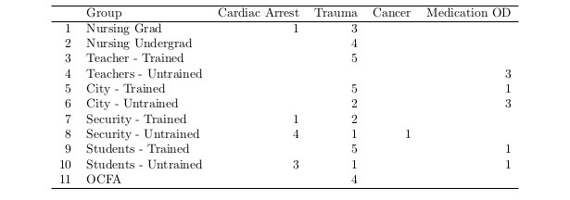

Question 2, “What do you think is the standard response time for a medical emergency when 9-1-1 is called?” was answered correctly as 8-11 minutes by only 35% of the trained individuals and 11% of the untrained individuals (Table 2). A majority of participants believed the correct answer to be 5-7 minutes, but the EMS standard is recognized as 8 minutes, nationally.

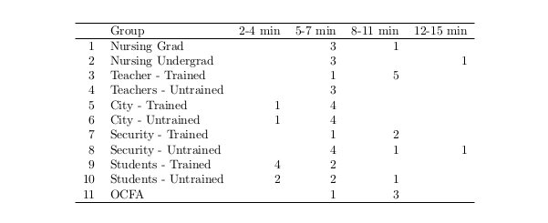

Most participants’ primary concern following a disaster or emergency situation (Question 3) was widely identified as safety at 86% (Table 3) Of interesting note, no participants answered treating victims as their main concern.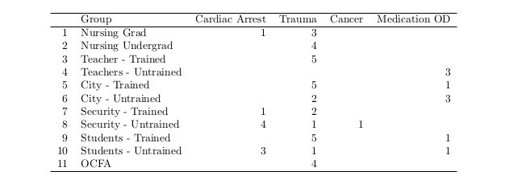

For Question 9, when applying a tourniquet to someone who is bleeding and they ask to remove it because it hurts, the correct response is to reassure them and leave the tourniquet in place, as it could prevent the victim from exsanguination. All participants nearly unanimously identified this, with 88% responding correctly (Table 4)

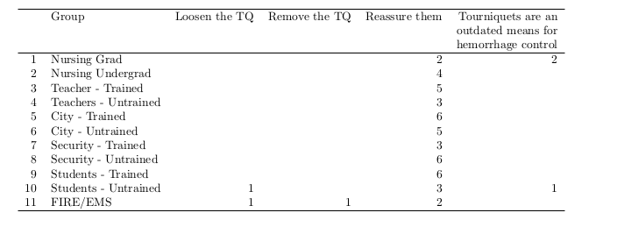

Finally, for reasons to not render aid in an emergency situation, both groups were split across three answers: not knowing what to do, unsure if their assistance would make the victim worse, and their concern for disease. Only two test participants identified litigation as a reason to not render aid in an emergency situation (Table 5).

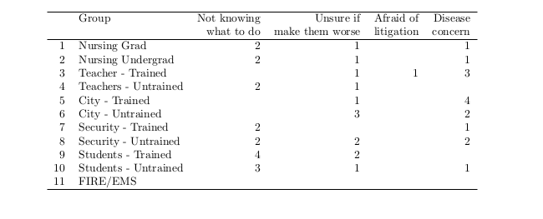

Simulation Results

Time to 1st Action

Arterial Bleed Station

In our earthquake simulation, victims were timed and their first actions were monitored and recorded. When responding to the victim suffering from an arterial bleed, the trained group performed their first action with an average time of 34.75 seconds, while the untrained group performed their first action with an average time of 111 seconds. EMS provided a first action baseline time of 48 seconds. All trained groups first action was to control the hemorrhage, either by direct pressure or through the use of a tourniquet. The untrained teachers and city workers did not treat this victim. The untrained security guards and students both made improvised tourniquets. It is worth noting that one of the untrained students was a former JROTC candidate. The registered nurses responded with a first action time of 1 minute and 15 seconds, and their first action was to evaluate the bleeding followed by tourniquet placement. The nursing undergraduate students simply applied ace wrap with a time of 1 minute. Only the untrained students and the OCFA address the open chest wound, which was covered by debris.

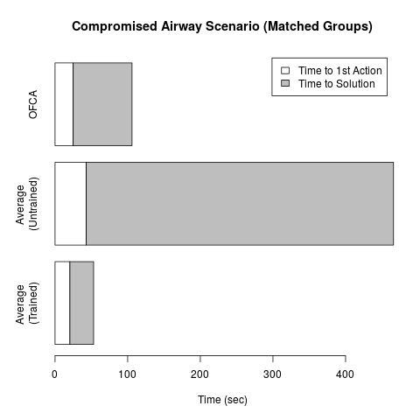

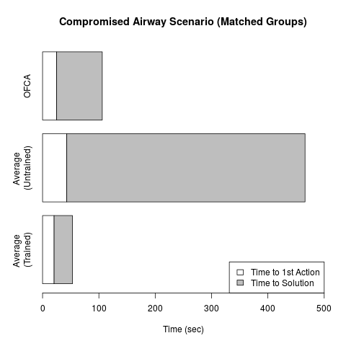

Airway Obstruction Station

The average time to first action of the trained groups responding to the airway compromised victim was 20.5 seconds, while the average time to first action of the untrained groups was 43 seconds. The trained groups first action time was similar to that of the OCFA, whom had a first time to action of 25 seconds. All trained groups placed the victims in the rescue position, which is an appropriate response. The untrained city worker and teacher groups both placed the victim in an unsustainable position that compromised the airway after several seconds. The OCFA first performed a jaw thrust, followed by leaving the victim in the rescue position. The registered nurses responded within 1 minute and 27 seconds and performed a jaw thrust on the victim, while the nursing undergraduate students simply performed CPR within 1 minute and 3 seconds.

Time to Solution

Arterial Bleed Station

When treating the arterial bleeding victim, the appropriate action is to hold pressure on the wound and/or apply a tourniquet to the effected extremity. With regards to treating the arterial bleeding victim, the trained groups had a remarkably lower time than the untrained group when responding and preventing death from exsanguination (which was designated at 8 minutes) (p-value = 0.001446, CI = (-infinity, -204.416)). The four trained groups had an average time to solution of 3 minutes and 33 seconds, while the four untrained groups were never able to come to a solution before time expired, and death fro exsanguination occurred. The average time to solution of the trained groups was similar to that of our baseline designated by the response time of the EMS workers, who had an average time to solution of 2 minutes and 38 seconds.

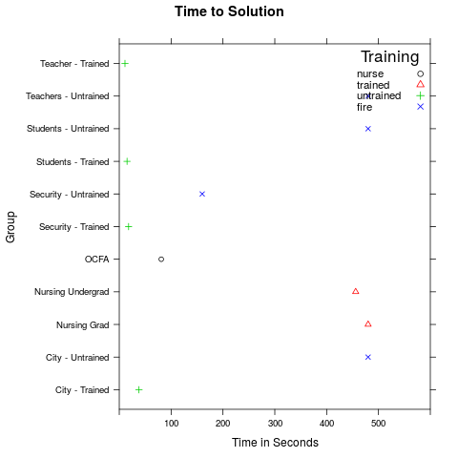

Airway Obstruction Station

When treating the unconscious victim, the proper maneuver is to place the victim on his side in the rescue position to prevent airway aspiration or obstruction. Once again, the trained groups saw a notably different time to resolution than that of the untrained group (p-value = 0.008729, CI = (-infinity, -191.5561)). The four trained groups had an average time to solution in 32.6 seconds, while the four untrained groups had an average time to solution of 7 minutes and 3 seconds. Of note, only one untrained group was able to come to a solution before time expired (security officers). Once again, the trained groups average time to solution closely mimicked that of the trained EMS workers who had an average time to solution of 1 minute and 21 seconds.

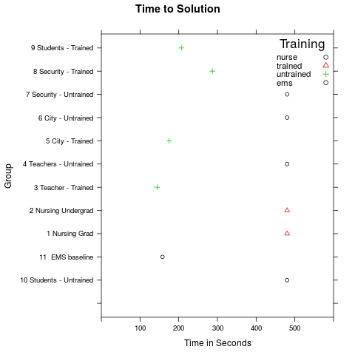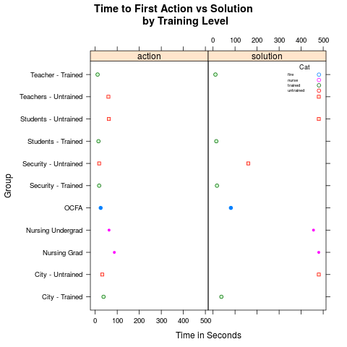

Discussion- Dr. Bobko